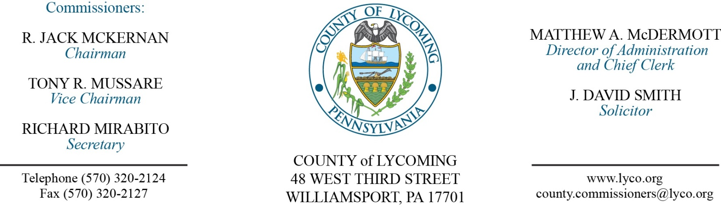
Commissioners’ Meeting Agenda
September 1, 2016

Opening Prayer

Observe moment of silence in observance of the passing of Judge Raup.

Pledge to the Flag

1.0 OPERATIONS

1.1 Convene Commissioners’ meeting.

1.2 Approve the minutes of the previous meetings.

1.3 Receive public comments (agenda items only).

2.0 ACTION ITEMS

2.1 Adopt resolution 2016-17 declaring property as surplus. (Jason Yorks)

2.2 Approve agreement with TCI of NY, LLC, in the amount of $4,195 for surplus equipment. (Jason Yorks)

2.3 Approve purchase from Susquehanna Motor Company, Inc. in the amount of $102,217.30 for 1-NEW 2017 Mack Truck Chassis with accessories. (Jason Yorks)

2.4 Adopt resolution 2016-18 for emergency repair phase II & III for pumps at White Deer Golf Course. (Mya Toon)

2.5 Approve purchase of washer for the Prison from Pac Industries in the amount of $11,146.00 off state contract. (Mya Toon)

2.6 Approve agreement with Keystone Communications for KeyCall remote monitoring system in radio towers and equipment room of the 9-1-1 Center in the amount of $92,589.46 off of COSTARS contract. (John Yingling)

2.7 Approve agreement with Youth Services Agency for the Juvenile Probation Department. (Ed Robbins)

2.8 Approve Juvenile Probation Grant-In-Aid application in the amount of $242,417.00. (Ed Robbins)

2.9 Approve amendment to agreement STEP for 2012 CDBG sub-recipient agreement. (Kristin McLaughlin)

2.10 Approve child welfare services contracts for July 1, 2015 – June 30, 2016 with the following: (Mark Egly)
• NHS Pennsylvania for foster care and residential care services at per diems ranging from $29.29/day to $157.04/day for the
• Children’s Choice, Inc. for foster care services at per diems ranging from $38.50/day to $82.30/day.

2.11 Approve child welfare services contracts for July 1, 2016 – June 30, 2017 with the following: (Mark Egly)
• Child Advocacy Center of the Central Susquehanna Valley to provide forensic child abuse interviews at the agreed upon rate of $100/ interview.

2.12 Approve Patricia A. Shipman, Esq. to provide Substitute Guardian Ad Litem services at the rate of $65/hour. (Mark Egly)

2.13 Approve Custodial Services Agreement with Hope Enterprises to provide weekly cleaning at the Agency’s 192 Beech Rd facility at the rate of $220/month during the first two years of the agreement and $225/month in the third year. (Mark Egly)

2.14 Approve the submission of the Lycoming County Children and Youth and Juvenile Justice Services Needs Based Plan and Budget request for the fiscal year July 1, 2017 to June 30, 2018 in the amount of $14,260,273. (Mark Egly)

2.15 Approve the following personnel actions: (Ann Gehret)
RMS - Daniel A. Watkins as full time replacement Equipment Operator – Pay grade 6 - $16.42/hour effective 9/6/16.
Prison – Renee E. Koons as full time replacement Female Correctional Officer I Relief M/F – COI - $15.54/hour effective 9/11/16.
Prison – Mark D. Siple as full time replacement Correctional Officer I Relief – COI - $15.54/hour effective 9/4/16.
PCD – reclassification of David L. Hubbard as Zoning Officer – Pay grade 7 - $34,940.16/annually effective 10/9/16, due to being fully qualified.

5.0 REPORTS/INFORMATION ITEMS

5.1 LCRMS is requesting 2 New 75 Cubic Yard Transfer Trailers. (Jason Yorks)

5.2 2016 CDBG project review. (Kristin McLaughlin)

6.0 PUBLIC COMMENT:

7.0 NEXT REGULARLY SCHEDULED MEETING: Planning Session on Tuesday, September 6, 2016.

8.0 ADJOURN COMMISSIONERS’ MEETING.

